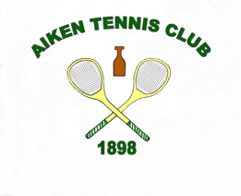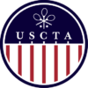

**US 70’s SINGLES & DOUBLES CHAMPIONSHIPS**

***THE AIKEN TENNIS CLUB***

***FEB 7-9***

***TOURNAMENT CHAIR – MIT CAROTHERS***

***EMAIL*** [***NICK@AIKENTENNISCLUB.COM***](mailto:NICK@AIKENTENNISCLUB.COM) ***BY 30TH JANUARY TO ENTER***

***ALL PLAYERS MUST BE CURRENT USCTA MEMBERS AND HAVE RECORDED THREE MATCHES INTO THE RTO SYSTEM IN THE PAST THREE MONTHS PRIOR TO THE TOURNAMENT ENTRY DEADLINE***

***ENTRY FEE: $185 FOR SINGLES & DOUBLES OR $145***

***FOR JUST SINGLES OR DOUBLES***

***ENTRY DEADLINE: JAN 30th, 2025***

***ENTRY INCLUDES TOURNAMENT FAVOR,TROPHIES, MARKING ,BACKDRAW,***

***FRIDAY EVENING WELCOME COCKTAILS/SATURDAY LUNCH, SUNDAY CONTINENTAL BREAKFAST***

*This is a level, single-elimination tournament*

*There will be a consolation round for first round match losers*

*\*please ask if you would like to be billeted.*