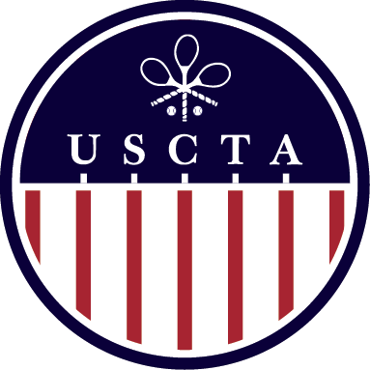

***USCTA Over 50’s Singles & Doubles***

***Racquet Club of Chicago***

***March 21st – 23rd 2025***

***Tournament Chairman: Jonathan Lewis***

***REGISTRATION FORM***

***must be filled out completely and emailed to:*** [***steve@racquetclubchicago.org***](mailto:steve@racquetclubchicago.org)

|  |
| --- |
| ***Name:*** |
| ***Doubles Partner:*** |
| ***Cell Phone:*** |
| ***Email:*** |
| ***Date of Submission:*** |
| ***Hotel room required:*** |

ENTRY FEE FIRST EVENT: $215

SECOND EVENT: $60

ENTRY DEADLINE: MARCH 14TH 2025

ENTRY INCLUDES TROPHIES, COURT FEES, MARKING FEES,

FRIDAY NIGHT COCKTAILS & HORS D’OEUVRES, SATURDAY LUNCH,

SUNDAY COFFEE & PASTRIES

**THE ENTRY FEE ALSO INCLUDES A TICKET TO THE WORLD CHAMPIONSHIP**

**FIRST ELIMINATOR MATCH ON THURSDAY MARCH 20 at 5PM**

**BETWEEN STEVE VIRGONA AND JOHN LUMLEY**

DUE TO THE EXPECTED SIZE OF THE DRAW

PLAY WILL BEGIN ON FRIDAY MORNING AT 9AM

PLEASE PLAN ACCORDINGLY

CONTACT STEVE VIRGONA FOR SCHEDULING REQUESTS

THE EVENT WILL BE RUN IN ACCORDANCE WITH THE

USCTA AGE LEVEL TOURNAMENT POLICIES