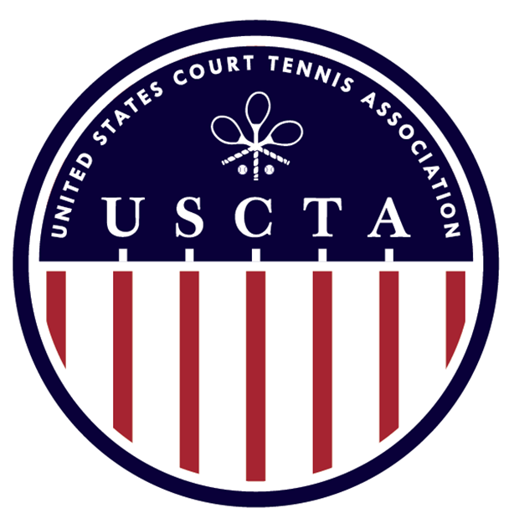

The 2024 Hickey Cup
January 26th to 28th

Georgian Court University in Lakewood NJ

Rules
This event is a Level National Singles Championship for players with handicaps of 60 and higher.
To enter you must be a current USCTA member and have at least three matches recorded in RTO in the 90 days prior to playing the event.

Entry Fee $100
This includes at least two marked matches, court fees, trophies, and lunch on Saturday

PLAY BEGINS FRIDAY MORNING. IF YOU HAVE SPECIFIC SCHEDULING REQUIREMENTS, WE WILL DO OUR BEST TO ACCOMMODATE YOU.

For more information or to enter please email James Greenley:

james@westwoodcc.com

Entries will close on Monday the 15th of January 2023

Georgian Court University, 900 Lakewood Ave, Lakewood NJ 08701

Phone: +1 571 338 8305

