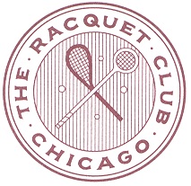

USCTA LEVEL CHAMPIONSHIPS
THE NOLL CUP
(HANDICAPS 30-39)
Racquet Club of Chicago
January 28th – January 30th 2022
Tournament Chair: Jonathan Lewis

2022 NOLL CUP REGISTRATION ForM

must be filled out completely and emailed to: steve@racquetclubchicago.org by January 20th 2022
Name:
cell phone:
home club:
email:
Date of Submission:
racquet club hotel room required:

ALL PLAYERS MUST BE CURRENT USCTA MEMBERS AND HAVE RECORDED THREE MATCHES INTO THE RTO SYSTEM IN THE PAST THREE MONTHS PRIOR TO THE TOURNAMENT ENTRY DEADLINE

ENTRY FEE: $175
ENTRY DEADLINE: JANUARY 20th 2022
ENTRY INCLUDES COURT FEES, MARKING FEES, PRIZES,
FRIDAY NIGHT COCKTAILS AND HORS D’OEUVRES,
SATURDAY CONTINENTAL BREAKFAST

DUE TO THE EXPECTED SIZE OF THE DRAW
PLAY WILL BEGIN ON FRIDAY MORNING
PLEASE PLAN ACCORDINGLY
CONTACT STEVE VIRGONA FOR SCHEDULING REQUESTS

This is a level, single-elimination tournament
Each main draw match is scheduled to be 2 out of 3 sets
There will be a consolation round for first match losers

