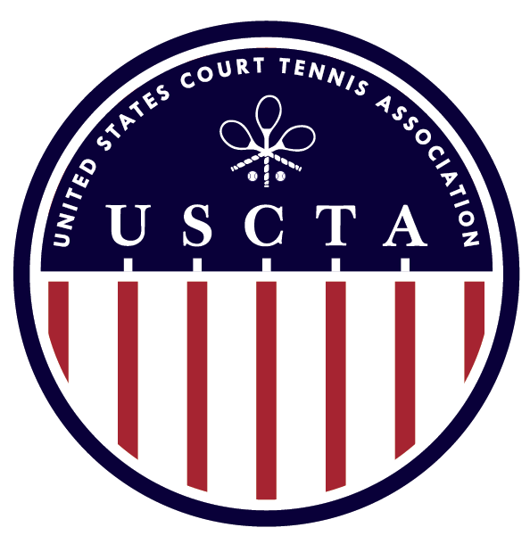

USCTA JUNIOR NATIONALS
SINGLES & DOUBLES
U26

April 17-19 2020
PRINCE’S COURT

ENTRY FEE: $50 TOTAL (Includes entry to all events)
ENTRY DEADLINE: TUESDAY APRIL 7TH

ENTRY INCLUDES: SATURDAY & SUNDAY BREAKFAST, SATURDAY LUNCH, COURT FEES AND MARKING

Matches in the main draw are scheduled to be best of 3, 6 game sets but this may change depending on the number of entries.
There will be a back-draw. Format depends on the size of the main draw.
Matches may start Friday April 17th. If you have scheduling preferences/requirements or need billeting please contact the Proshop.

To enter please email Pros@PrincesCourt.com

Prince’s Court Proshop: Ivan Ronaldson 703 556 8801

Prince’s Court
Mclean Sport and Health
1800 Old Meadow Road
Mclean VA 22102

