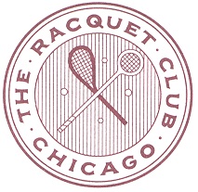
USCTA LEVEL CHAMPIONSHIPS
THE NOLL CUP
(HANDICAPS 30-39)
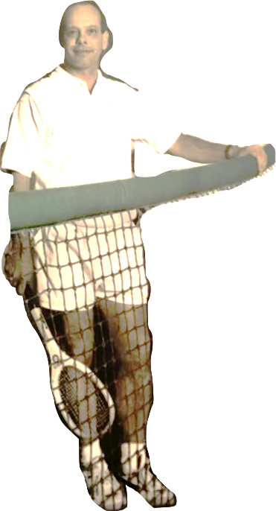

Racquet Club of Chicago
January 31st – February 2nd 2020

2020 NOLL CUP REGISTRATION ForM
must be filled out and emailed to: steve@racquetclubchicago.org by January 24th 2020
Name:
Daytime Phone:
Cell Phone:
Email:
Date of Submission:
A Credit Card will be a requirement upon Arrival

ALL PLAYERS MUST BE CURRENT USCTA MEMBERS AND HAVE RECORDED THREE MATCHES INTO THE HANDICAP SYSTEM IN THE PAST THREE MONTHS

ENTRY FEE: $175
ENTRY DEADLINE: JANUARY 24th 2020
ENTRY INCLUDES COURT FEES, MARKING FEES, PRIZES,
SATURDAY TOURNAMENT LUNCH,
SUNDAY CONTINENTAL BREAKFAST

DUE TO THE EXPECTED SIZE OF THE DRAW
PLAY WILL MOST LIKELY BEGIN ON FRIDAY MORNING
PLEASE PLAN ACCORDINGLY
CONTACT THE PRO SHOP FOR SCHEDULING REQUESTS

This is a level, single-elimination tournament
Each match is scheduled to be 2 out of 3 sets
There will be a consolation round for first match losers

