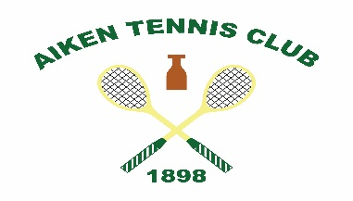
THE AIKEN TENNIS CLUB PRESENTS
THE NORTHROP KNOX TOURNAMENT
APRIL 18th – 21st, 2019
DOUBLES TOURNAMENT FOR PLAYERS HANDICAPPED 35 AND UNDER
GUARANTEED THREE, BEST OF THREE SET MATCHES

TOURNAMENT ENTRY FEE OF $295 INCLUDES ALL SOCIAL EVENTS
THURSDAY OYSTER NIGHT WITH OPEN BAR AND HEAVY HORS D’OEUVRES
FRIDAY NIGHT TENNIS WITH COCKTAILS AND LIGHT HORS D’OEUVRES
SATURDAY NIGHT DINNER AND OPEN BAR AT THE CLUB
SUNDAY BRUNCH AT NOON

A LA CARTE FOR GUESTS:
OYSTER NIGHT: $45
FRIDAY NIGHT TENNIS: $25
SATURDAY DINNER: $60

RSVP BY CONTACTING THE TENNIS PROFESSIONAL BY MONDAY, APRIL 8th
Trey Bogue: (386) 675-7802 or treybogue@gmail.com
Per tradition, the ATC provides complimentary lodging for visiting players.
If interested, contact Dan Mayfield: (803) 643-9760 or dmayfield@dobbsbrothers.com

