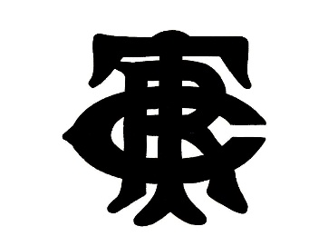

US Amateur Singles
April 21st to 23rd
Tennis & Racquet Club - Boston

This prestigious event attracts the top amateur players from around the USA. Alongside the singles we will also be running an organized round robin doubles event at no extra charge.

You must be a current member of a national court tennis associations (USCTA, T&RA, ARTA). RTO handicap will be used for seedings.

Entry fee is $110.
This includes marking, court fees, trophies, round robin doubles, Saturday and Sunday continental breakfast, Saturday lunch, and a commemorative gift.

DUE TO THE ANTICIPATED SIZE OF THE DRAW ALL PLAYERS MUST BE READY TO PLAY FRIDAY MORNING

Please complete and return the entry form to Tony Hollins on Tony.Hollins@TandR.org
Entries will close on Friday, April 14th at noon. The T&R Proshop number is (617) 536-4630.

Tournament Director – Tony Hollins – tony.hollins@tandr.org
Tournament Chair – Jeff Horine – jeffrey.horine@gmail.com

Name……………………………………………………………………. Handicap:…………………

Club Affiliation:…………………………………………………….. RR Doubles? Yes or No

Contact Information

Phone:……………………………………………………………………

Email:……………………………………………………………………..

