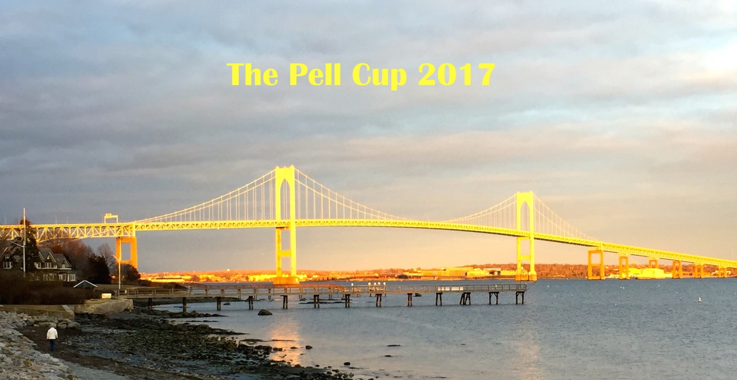

August 17th – 20th

National Tennis Club, Newport RI



Entry Fee: $250

Cocktail party – Thursday 17th, 5:30 – 7:30pm – NTC

Cocktail party – Friday 18th, 5:30 – 7.30pm - NTC

Dinner Saturday 19th, 8:00 – 9:30pm – Conanicut yacht Club, Guests Welcome, $75

Brunch – Sunday 19th, 10:00 – noon – NTC

DIVISIONS

Including the Open Doubles, there will be a maximum of 6 divisions. Teams will be assigned to divisions based upon the number of entries and the handicap level of the team (this is not a handicap event, however). Due to the popularity of this event, there will be a maximum of 32 teams. You must have a partner to enter. *If you are under 18, you must have a club handicap of 35 or better, to be eligible to enter the event.*

### Format

It will be a round robin format. Due to the anticipated size of the tournament, all players must be prepared to play by 8:00 AM on Thursday, August 17th. Local players may be given playing assignments on Wednesday, August 16th**.**

Sponsorship

We hope that you will consider being a sponsor at the Clarry Pell level ($1,000 and above), at the George Wharton level ($500 to $999), or at another level suitable to your means.  One hundred percent of sponsor donations will go to the professional’s prize purse.  The professionals are the teachers and competitors whose active participation in events such as the Pell Cup is essential to keeping our sport healthy, and attracting new generations of players.

Auction

We will also be conducting an auction of attractive items to benefit the programs of the National Tennis Club. The items to be auctioned will include court tennis memorabilia, works of art, culinary delights, and recreational and athletic outings.  The silent part of the auction will be on-going throughout the tournament.  We also expect that at the Saturday dinner some items of interest will be sold at live auction.

Look Forward to seeing you in Newport

Entries only taken through the website [www.nationaltennisclub.org](http://www.nationaltennisclub.org)