2017 US 50’s Tournament
Friday March 24th – Sunday March 26th

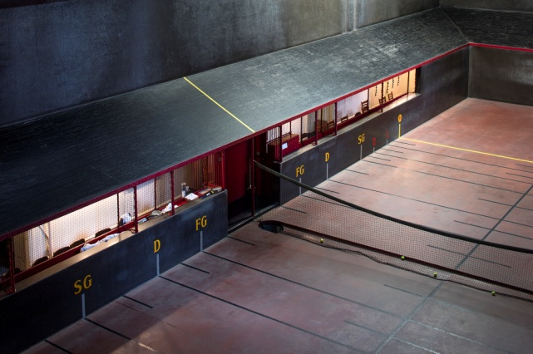

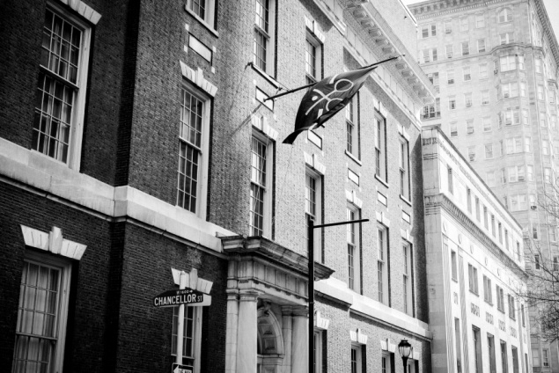

The entry fee is just $135 and includes all matches marked, both Singles & Doubles with a Friday Night dinner and Saturday morning Brunch. A Tournament favor is also included.

Depending on the size of the draw, players should be prepared for Friday afternoon matches.

Please fill in the information below and send to johnlumley@rcop.com. Have any questions about the tournament? Call 215-772-1544.
Payments for the draw will be collected upon arrival to the club.

Name:

Handicap:

Phone number:

Email:

Doubles Partner:

Doubles Partner email:

