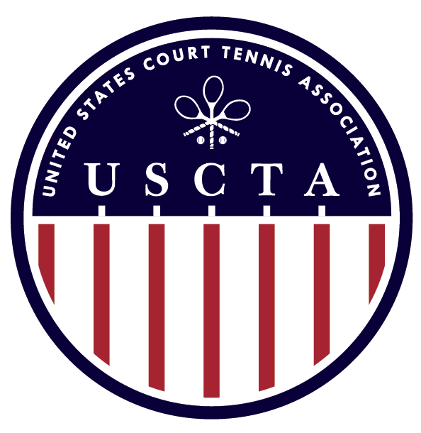

USCTA JUNIOR NATIONALS
U13, U15, U17 & U19 SINGLES

JULY 22ND – 24TH, 2016
THE TUXEDO CLUB
TUXEDO PARK, NY

ENTRY FEE: $50 PP
DEPENDING UPON THE DRAW SIZE, PLAYERS MAY BE LIMITED TO PARTICIPATING IN TWO FLIGHTS.
ENTRY DEADLINE: MONDAY JULY 18th, 2016
ENTRY INCLUDES:
SATURDAY & SUNDAY CONTINENTAL BREAKFAST
TOURNAMENT PRIZES
TOURNAMENT FAVOR
SATURDAY NIGHT BARBECUE
MARKING

**Please let Tim Chisholm know if you would like housing**

ALL U.S. PLAYERS MUST BE CURRENT MEMBERS OF THE USCTA

Please Send Your Completed Entry Form to tchisholm@thetuxedoclub.org
The Tuxedo Club Racquets Director: Tim Chisholm (845) 351-7345

USCTA JUNIOR NATIONALS ENTRY FORM

NAME _________________________________________________________________________

EVENT
U13 __________
U15 __________
U17 __________
U19 __________

CELL PHONE _________________________________________________________________________

E-MAIL ________________________________________________________________________

WILL YOU REQUIRE HOUSING? _____________________________________________________

IF YES, HOW MANY? ______________________________________________________

Please return form to Tim Chisholm, The Tuxedo Club – tchisholm@thetuxedoclub.org

