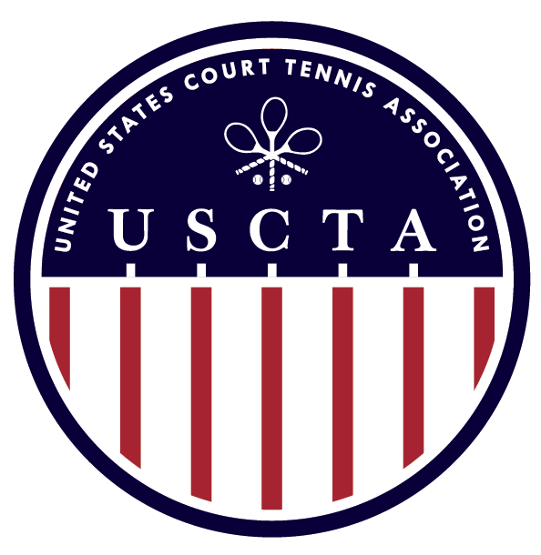

USCTA MIXED DOUBLES
NATIONAL CHAMPIONSHIP
&
GREEVY CUP (HCP 20-29)

JUNE 10TH -12TH, 2016
THE TUXEDO CLUB
TUXEDO PARK, NY

USCTA MIXED DOUBLES
ENTRY FEE: $100 PP
ENTRY DEADLINE: WEDNESDAY JUNE 1ST, 2016
ENTRY INCLUDES:
SATURDAY & SUNDAY CONTINENTAL BREAKFAST, TOURNAMENT PRIZES,
TOURNAMENT FAVOR AND MARKING FEES

USCTA GREEVY CUP (HCP 20-29)
ENTRY FEE: $125 ($75 IF PLAYING IN MIXED DOUBLES AS WELL)
ENTRY DEADLINE: WEDNESDAY JUNE 1ST, 2016
ENTRY INCLUDES:
SATURDAY & SUNDAY CONTINENTAL BREAKFAST, TOURNAMENT PRIZES,
TOURNAMENT FAVOR AND MARKING FEES

**There MAY NOT be a back draw depending upon the number of entrants**
**Matches will be played starting at 9 AM on Friday June 10th**
**Please let Tim Chisholm (and make a note on entry form) if you and/or your team are available to play on Thursday June 9th**

ALL U.S. PLAYERS MUST BE CURRENT MEMBERS OF THE USCTA

Please Send Your Completed Entry Form to tchisholm@thetuxedoclub.org
The Tuxedo Club Racquets Director: Tim Chisholm (845) 351-7345

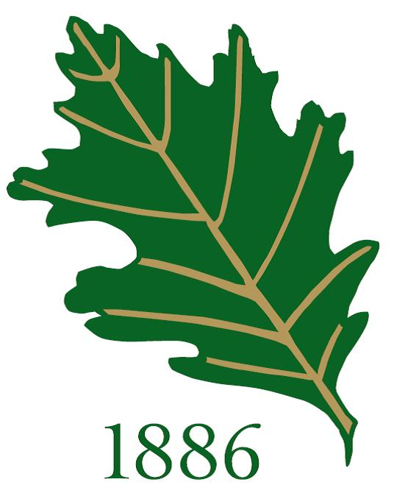

USCTA MIXED DOUBLES NATIONAL CHAMPIONSHIP
& GREEVY CUP ENTRY FORM

NAME _________________________________________________________________________

EVENT
MIXED DOUBLES __________ PARTNER ________________________
GREEVY CUP __________

CELL PHONE _________________________________________________________________________

E-MAIL ________________________________________________________________________

WILL YOU REQUIRE HOUSING? _____________________________________________________

IF YES, HOW MANY? ______________________________________________________

Please return form to Tim Chisholm, The Tuxedo Club – tchisholm@thetuxedoclub.org

