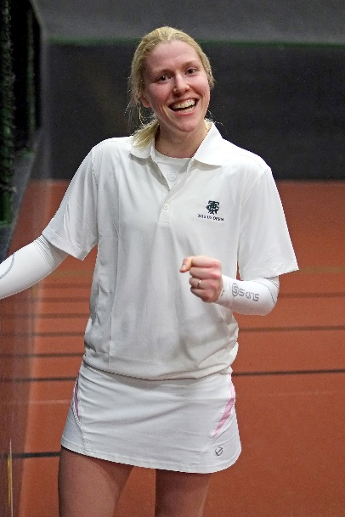
The 2015 US Open kicked off today with a match between Mike Gooding, who has won numerous Open championships, and Boston’s Jeff Horine, one of two amateurs in the singles field. Horine played inspired tennis and took the match to one set all and 5/5, 30-30 the third set before succumbing in four sets to the steady play from Gooding.
The second match of the tournament featured the second amateur in the singles field, Boston’s Jeremy Wintersteen, against Josh Bainton, a finalist in an Open doubles championship and winner of four Pell Cups. Wintersteen continued the strong amateur play and took the match to one set all and 3/3 before being overtaken by Bainton’s excellent recovery shots, also falling in four sets.
Next up, Adrian Kemp defeated Matty Ronaldson in straight sets 6-2, 6-4, 6-4.
Then came the match that threw us off schedule: John Lumley vs. Darren Long. It was a brutal three hour contest—one of the most physical I have seen in a while. Some extremely long points. In the end Lumley, after losing the first set, came out on top 4-6, 6-5, 6-5, 6-0.
The cocktail matches featured T&R’s head pro, Tony Hollins vs. Neil Mackenzie. Tony won the first two games and never looked back. He was never behind in the match. Despite some difficulty finding the floor on his service return, Hollins took it handily 6-3, 6-2, 6-1.
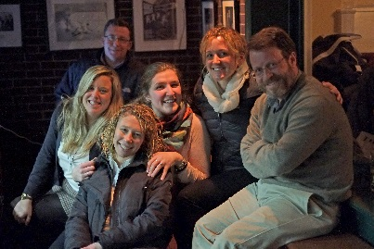
An historical match ended the night: Ladies’ World Champion Claire Fahey vs. Middlesex’s Leon Smart. Claire is the first woman to enter the singles draw in the US Open, and there were dozens of supporters rooting her on.
Claire dominated from the start. The first set showed us how much she loves backhand volleys: she put a dozen or so into the base of the tambour. She also maintained serve by hitting galleries. Her strategy worked, as she took the first set 6-0.
The second set was rather different. The first half was very tight, with games being swapped up to 3-3. Then, for the first time, Smart pulled ahead to 4-3. The ninth game of the set was very hard fought, with some long rallies, but Smart took it. He was up 5-4. One more game and the set was his. The tenth game was absolutely epic, with an amazing 11 deuces and 6 set points for Smart. Claire proved her tenacity by defending all six of those set points and ultimately tying it up at 5-5. In the final game, the players switched at 30-30 after Claire had a lucky roller along the dedans wall for chase better than half. Smart appeared to hurt his calf in the second last point, or perhaps it was cramps. Claire used it to her advantage and took the second set 6-5.

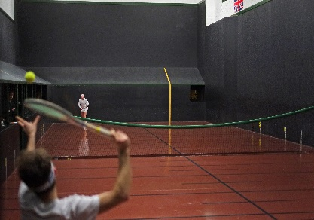
The third set was a mix of the first two. Claire’s consistent floor game was giving Smart trouble, while Smart’s accurate railroad was forcing Claire to hit too many defensive returns. Claire first went to 3-1. After Smart took the fifth game to go 2-3, Claire put the pedal down and ran it up to 5-2. She stalled for a couple games, hitting the net tape a couple times. This allowed Smart, amid an injury break and some limping, to bring it back to 4-5. Claire however would not be denied. Smart came over to serve at 40-15 Claire. He defended the chase, one of Claire’s set points. But she could not be withstood. Claire Fahey took the last set 6-4.
Next up for Claire in singles is her second round match against Chris Chapman on Saturday at 10:00 a.m. Tune in to the USCTA’s youtube channel to catch that one and all the matches.

