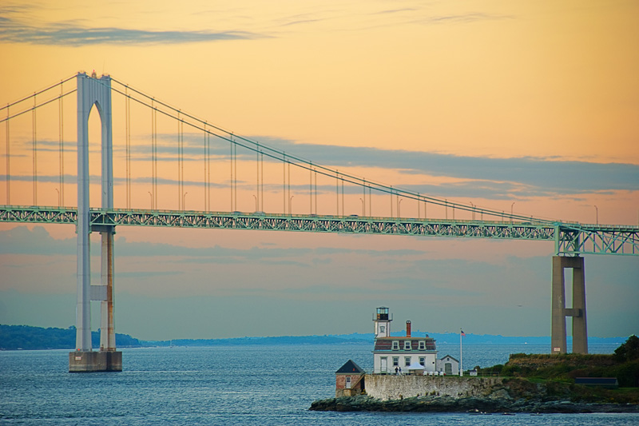

August 13th – 16th
National Tennis Club, Newport RI
Doubles flighted & open divisions
Entry Fee: $200
Cocktail party – Thursday 13th, 5:30 – 7:00pm - NTC
Clambake – Friday 14th, 6:30 – 9:30pm – Kempenaar’s
Brunch – Sunday 16th, 10:00 – noon – NTC

Please visit www.nationaltennisclub.org or email Camden@nationaltennisclub.org
Players must be available for play 9am Thursday, August 13th

