U.S. OVER 60’s - 2014
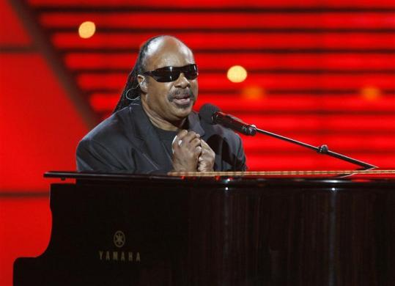
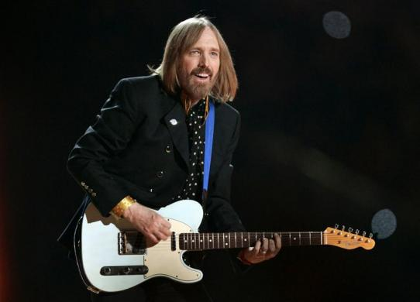
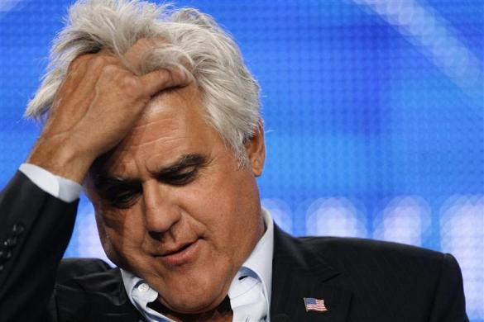
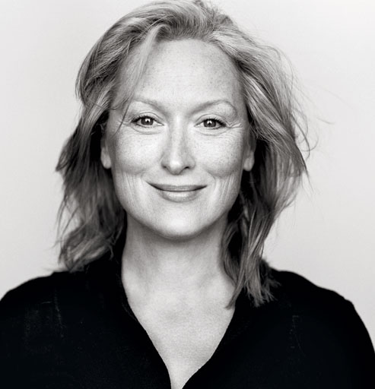
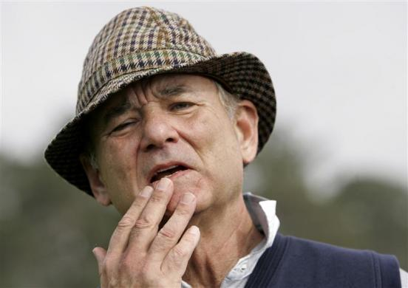
Tom Petty, Richard Branson, Stevie Wonder, Bill Murray, Jay Leno, Meryl Streep:

All ELIGIBLE THIS YEAR!!!!!!
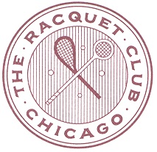

Over 60’s SINGLES AND DOUBLES 2014
Racquet Club of chicago
March 21st – March 23rd
REGISTRATION FROM
must be filled out completely and emailed to: rccpros@aol.com by MARCH 15th 2014
Name:
Daytime Phone:
Cell Phone:
Email:
Date of Submission:
A Credit Card will be a requirement upon Arrival

ENTRY FEE FIRST EVENT: $100
SECOND EVENT $25
ENTRY DEADLINE: MARCH 15th 2014
ENTRY INCLUDES COURT FEES, MARKING FEES,
SUNDAY CONTINENTAL BREAKFAST

DUE TO THE EXPECTED SIZE OF THE DRAW
PLAY WILL MOST LIKELY BEGIN ON FRIDAY MORNING
PLEASE PLAN ACCORDINGLY
CONTACT THE PRO SHOP FOR SCHEDULING REQUESTS

Each match is scheduled to be 2 out of 3 sets
There will be a consolation round for first match losers

